Haylock, Kevin (from Linked In website)
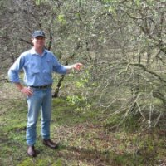
Educated at Bunbury Catholic College.

Director Sandalwest 2008 – Present (5 years)
Kevin has 30 years’ experience in managing native forest and plantation operations in the south west of Western Australia including seven years as Manager of Native Forest Operations for the Forest Products Commission (FPC).
Key points of his career include:
• Fire control
• Regeneration operations include regeneration burning
• Sale of forest products under commercial arrangements
• Consultation with Native Title Claimants
• Liaison with conservation groups
• Forest protester management
• Media liaison.

Manager in Forest Products Commission 2000 – 2008 (8 years).

Forester Western Australian Department of Environment and Conservation 1985 – 1999 (14 years). In Pemberton 1989, Forester in Kirup 1989. Forester in Harvey 1991.

